Principles of Signal Analysis

Narrowband Signals

A narrowband signal has frequency support only in a limited range of frequencies with bandwidthcentered around a frequency. Narrowband signals also include the class of signals where the majority frequency content is localized near the center frequency, for example the function has bandwidth . The study of narrowband signals arises when either a filter or a channel constrains the passband to occupy only a narrow range of frequencies.

The complex time envelope is

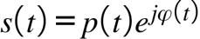

where the real amplitude p(t) is assumed to have unit energy and the phase phi(t) is in [-pi pi]. The corresponding frequency spectrum is denoted

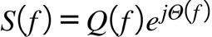

Draw figure of modulated amplitudes and baseband complex envelope spectrum. We will assume the envelop has unit energy.

The Analytic Signal

The complex baseband signal as described in section 14.2 is applicable only to modulated sine waves. Here we generalize this concept to a broader class of signals and provide a general mathematical foundation for the process. The utility of the analytic signal formulations is realized when describing narrowband signals. It is more efficient to deal with signals with only positive frequency which is accomplished in the analytic signal representation. This in turn leads to the complex envelope which contains the relative information or useful component of the signal separate from the carrier portion. This ease of tractability in performing analysis comes at the expense of a complex signal. In effect the real received signal is decomposed into two orthogonal directions which are all related through Euler’s formula and the Hilbert transform. Once we have the complex envelope we may process the signal by LTI systems using only baseband signals, including the impulse response. This transformation is Bijective in the sense that the real signal may be recovered from the analytic signal.

The analytic signal of a real waveform is defined as the inverse transform of the positive frequency spectrum contained in ,

where is the unit step function and the factor 2 is for convenience. Note that is necessarily complex because it possesses no symmetry (a real signal has an even FT) and has Fourier transform containing only positive frequencies,

Because real signals possess even Fourier symmetry the negative frequencies are redundant and are removed by the analytic signal formulation.

Using the convolution property for Fourier transforms and we may write as

where

is the Hilbert transform of . Using we see that,

i.e. in the frequency domain the Hilbert filter has the effect of shifting a complex exponential by ,

which for our example is as before.

The fundamental relationships between the analytic signal and the complex envelope are summarized in Table ()

In particular we shall not attempt to give strict conditions under
which the formulas hold; we assume that all the functions involved are
sufficiently well behaved for the various integrals to exist.

Input-Output Relationship

If define an LTI system then the output analytic signal is

or

Thus standard convolution with the impulse response determines the analytic signal output.

FIGURE OF MAG H AND ARG H

The analytic signal is also an analytic function of the complex variable

Example: Amplitude Modulation

An amplitude modulated communication signal transmitted over a bandpass channel is of the form

where is a “high” carrier frequency that shifts the narrowband information signal into the passband of the channel.

The analytic signal for is from

and the Hilbert transform is

where is an indented hemisphere in the complex w-plane. Thus

where is the standard complex envelope of a narrowband amplitude modulation described below.

The envelope is the magnitude of the analytic signal,

We may write as

where

are known as the inphase and quadrature components which are related to the signal quantities by the envelope and phase, respectively,

The inphase and quadrature phase components each carry and information bearing signals which are projected onto carrier waves that are displaced from each other by 90 degrees, hence the word quadrant->quadrature. We may then write as

where the complex baseband signal or complex envelope is defined as

In this way we have isolated the signal quantities of interest at baseband and enabled mixing to be performed merely by multiplying by a complex sinusoid, all at the expense of introducing complex numbers. In essence then the complex baseband signal combines information bearing amplitude and phase into a single manageable quantity with spectrum concentrated around DC . We note in passing that the now complex carrier has only positive frequencies whereas its real counterpart has negative frequencies as well. The complex envelope has a spectrum that is localized around DC.

The input output for an LTI system also can be specified in terms of only the complex envelopes, i.e.

where

is the baseband complex envelope of the output. Therefore we have removed the dependence on the carrier for analysis.

Example 2: Real Narrowband Signal

Narrowband Noise Processes

Show lowpass diagram filter

Examples of Narrowband signals

Time limited cosine.

White Gaussian Noise Process

Waveform Parameters

Waveforms can be described in various ways, time, frequency, phase, derivatives, etc.

Phase, Instantaneous Frequency and Group Delay

Define the instantaneous frequency as the time derivative of phase

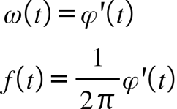

Differentiating the envelope and solving for the phase derivative yields

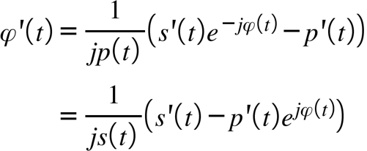

We can use this expression to measure the amount of linear frequency modulation in waveform by correlating the frequency with time and weighting by the amplitude squared

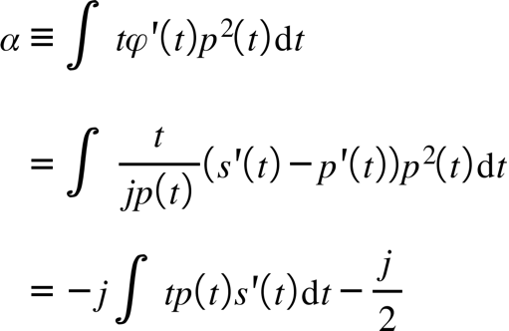

The last term is from partial integration of the rhs integral leads to

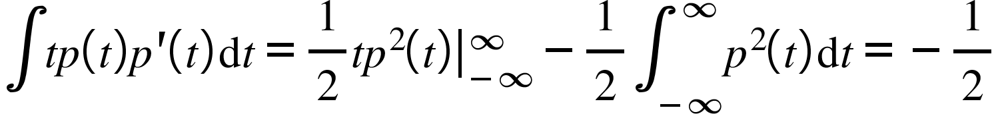

And p(t) vanishes at .

For complicated phase modulation it is often difficult to obtain closed form solutions to the Fourier transform when the bandwidth is required. For oscillatory integrals…The main idea of so called stationary phase methods relies on the cancellation of sinusoids with rapidly-varying phase. If many sinusoids have the same phase and they are added together, they will add constructively. If, however, these same sinusoids have phases which change rapidly as the frequency changes, they will add destructively. Hence the major contribution to the integral will occur at the point of stationary phase (either time or frequency depending upon which Fourier integral is required). For example, suppose the FT of the signal required, then we must evaluate

For most PM waveforms (i.e. nonlinear PM) the AM is slowly varying and the phase

is a rapidly varying function of time hence the principle of stationary phase applies. The stationary phase point t0 occurs as the solution to

Expanding in Taylor series

(middle term is zero)
Even when the excursion about t0 is large is still so large that the oscillatrions are still fast enough to have the integral evaluate to zero. Therefore we can extend the limits of integration beyond neighnborhood for a Taylor expansion, i.e. to the entire time support, and then even to infinity so that the FT can be evaluated.
However, most frequency spectrum will be contained around the stationary point and thus the corresponding frequency limits can be obtained by substituting t0=0 and t0=T.
Then

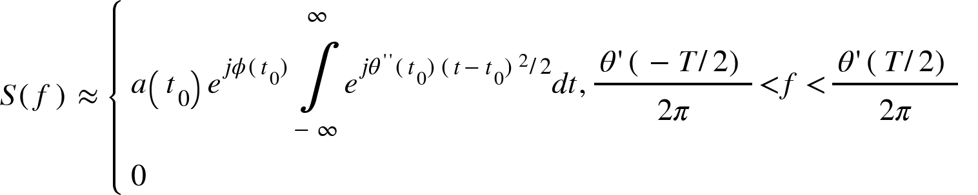

The range of frequencies over which the spectrum is appreciable is determined from the relationship between time and frequency under the condition of stationary phase.

After integrating the Gaussian, the result is

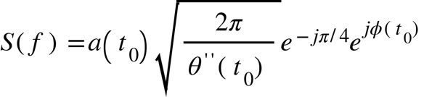

The approximation has been shown by Vakman to be accurate up to order 1/sqrt(BT).

Extending the limits to infinity is equivalent to assuming the bandwidth of the signal is much larger than the bandwidth of the observation time given by the sinc function 1/T, thus WT>>1 yet again. It makes sense that the amplitude is inversely proportionally to the curvature of phase at the stationary point (the first derivative is zero at t0), or the derivative of frequency because if the frequency is changing very fast (like a short pulse) then the spectrum contains many frequency components, i.e. its energy is more evenly distributed across frequency, than say a long pulse which changes slowly (more like a constant, which has a single frequency), which requires only a few Fourier basis functions.
Most of frequency is concentrated around the dwell time t0, therefore we expect the spectrum to decay inversely to frequency over the band which is given by the solution the stationary phase equation as t0 ranges from 0 to T.
The FT is convolved with a sinc which has BW 1/T, vs W=f2-f1, thus if W>>1/T, or WT>>1,large tb product, the spectrum is dominated by the HFM sweep. Thus if WT large, we may approximate the spectrum by its infinite FT which is the same as using the stationary phase argument, i.e. extending integral beyond small neighborhood around stationary point in the Taylor series. Most of frequency is concentrated around the dwell time

The phase stationary point t0 is known as the group delay. It is the amount of delay experienced by the small group of frequencies contained in the envelope of a narrowband signal. If we expand the envelope phase spectrum in a first order Taylor series

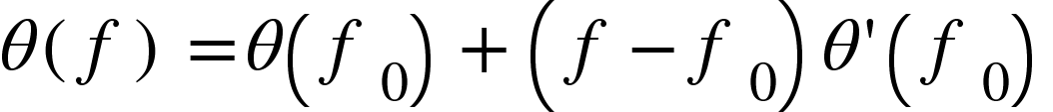

then the time function corresponding to the spectrum of a signal around f0, S(f-f0) is

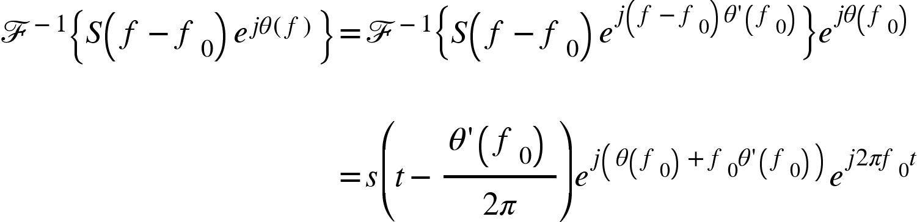

The signal is delayed by this amount around a small band centered at f0. It is the average time of arrival for the frequency f. For that band the group delay is

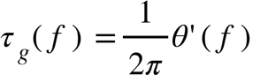

Equivalently using the stationary phase in frequency, in the converse domain we have

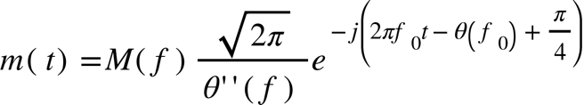

where f0 is the instantaneous frequency. Interestingly, under these approximations it can be shown the group delay and instantaneous frequency are inverse functions of each other

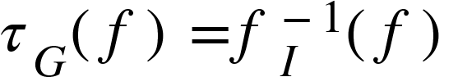

From () with m(t)=a(t)exp(jphi(t) the second derivative of the phase spectrum can be related to the frequency and time envelopes as

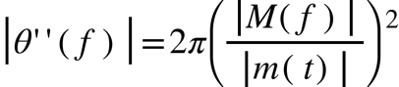

The relationship in () can be used to design waveforms with prescribed characteristics.

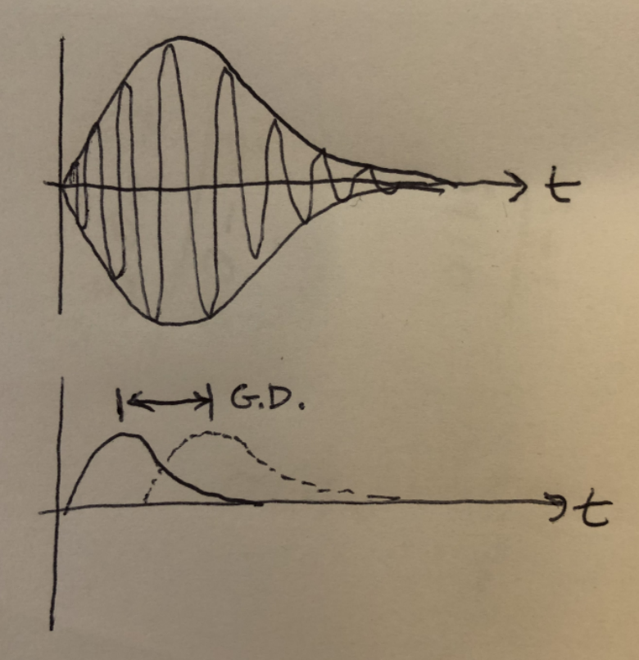
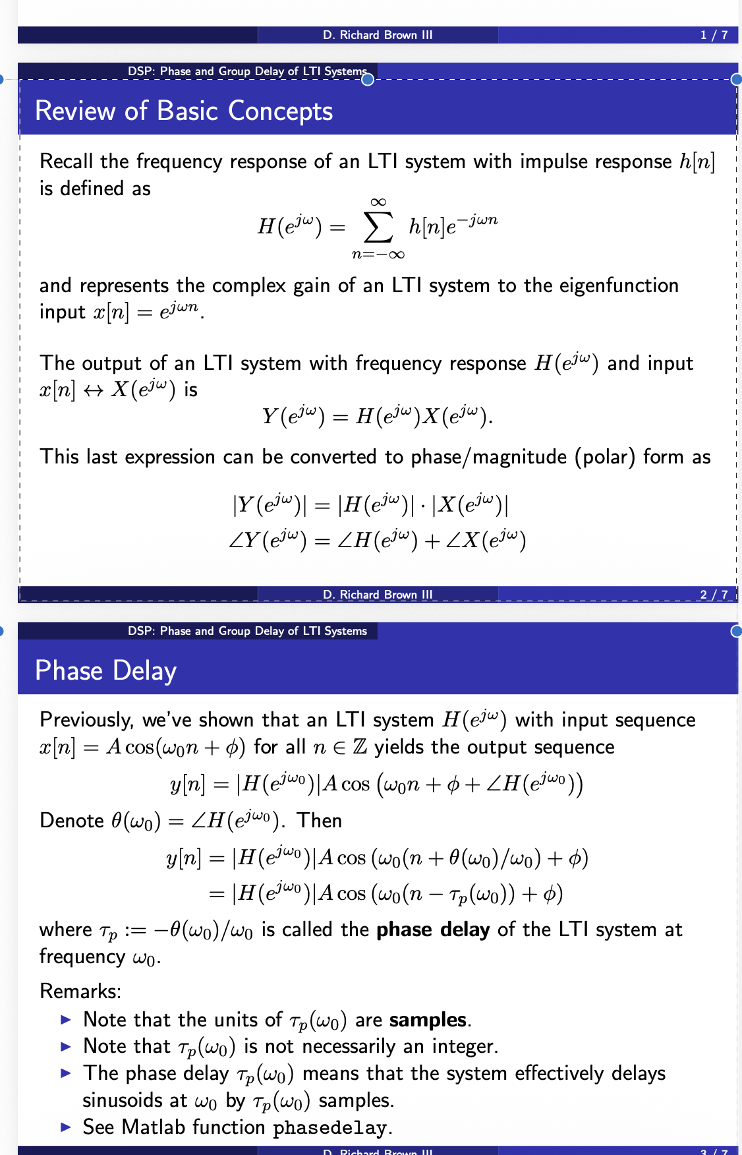
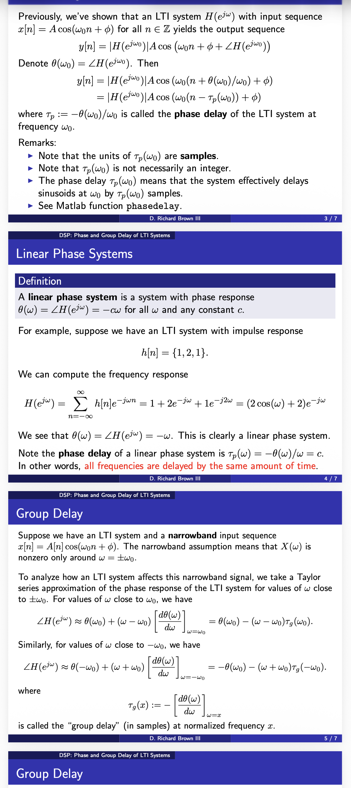
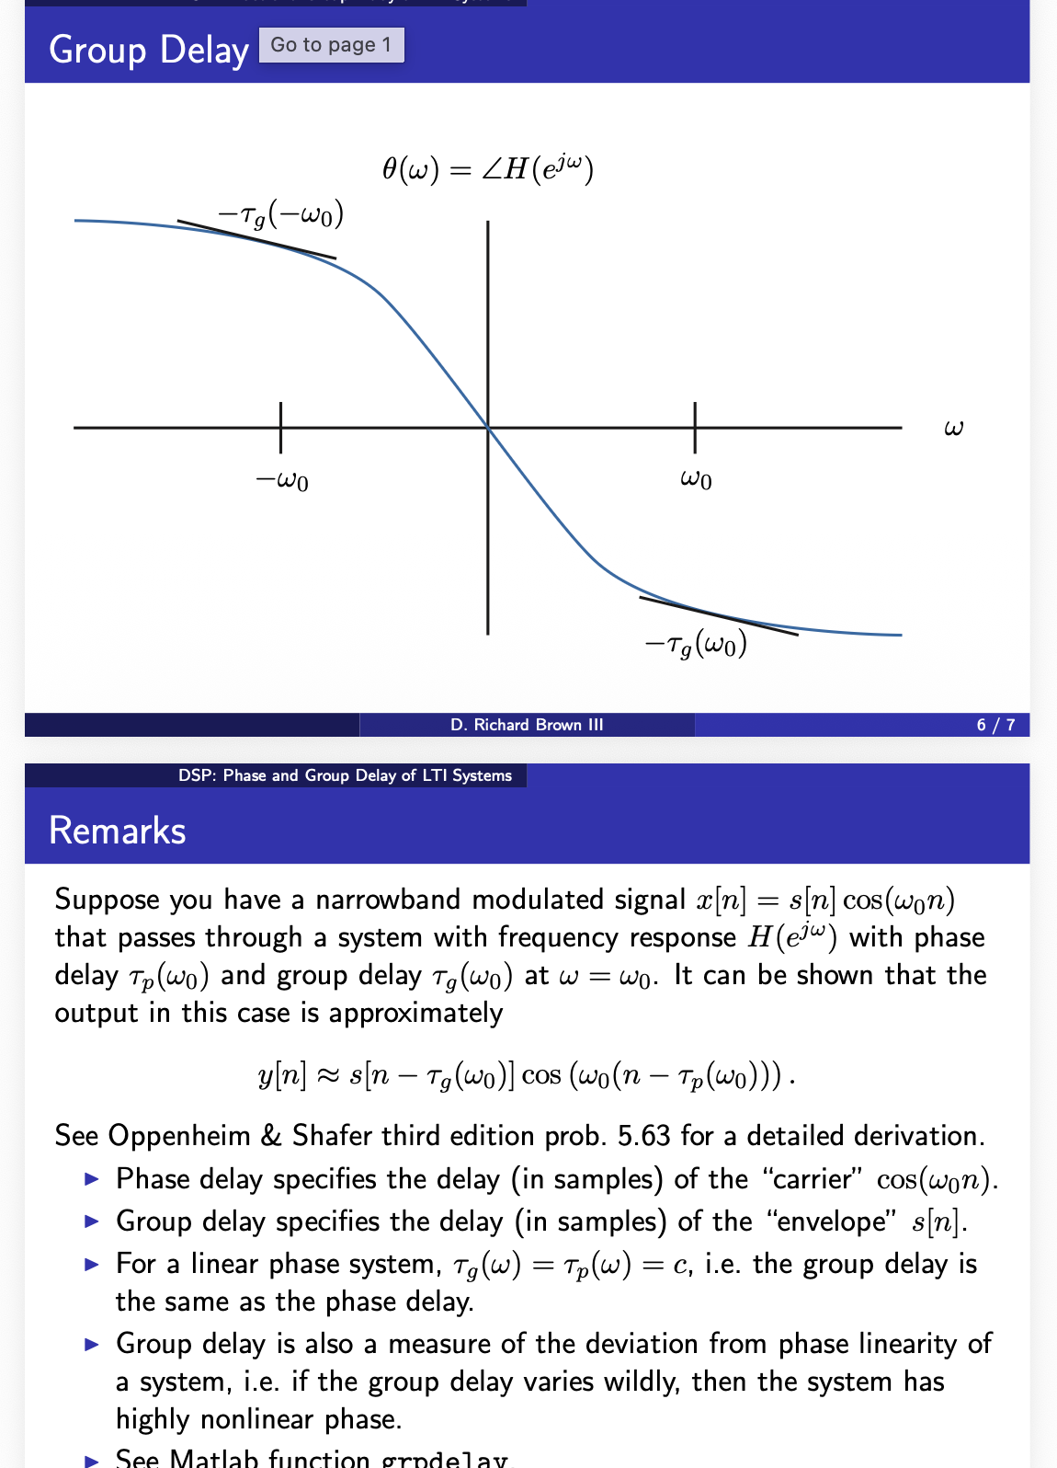

Frequency and Bandwidth

Bandwidth means that a system with bandwidth W will basically pass sinusoids up to frequency W. It is a measure of how quickly a continuous time function changes. Waveforms whose values change rapidly with time will have a large bandwidth, and conversely. The Fourier transform is used to characterize bandwidth for deterministic signals and the PSD for random signals, i.e. in terms of their correlation function. Remember the FT is merely a series expansion onto basis functions given by complex exponentials over all frequencies. If a Fourier transform has an appreciable value at a high frequency then the projection of the time function onto a complex exponential at that frequency will be larger, and the waveform will have a larger bandwidth.

A convenient zeroth order measure of the bandwidth of a signal is the equivalent energy rectangular spectrum, known as the equivalent noise bandwidth (ENBW). The ENBW represents the noise power the signal would have assuming a flat spectrum, with total power equivalent to the signal power. Mathematically this is defined as

that is, the total energy divided by its central ordinate, DC power. The two sided NEBW is illustrated in Figure (). The one sided version is computed over positive frequencies only.

The following are other definitions of bandwidth:

RMS Bandwidth

Full width half maxima, or -3dB bandwidth, given by the solution to

Zero Intercept Bandwidth

Example 16.1: Bandwidth of rectangular pulse

and

Zero intercept occurs at: therefore .
ENBW:

The 3dB frequency occurs when

or which occurs when from Figure (), so .

From the relationships

and () we have the reciprocal property

As an example, consider the autocorrelation function of the unit energy waveform ,

which has Fourier transform . From with , and using (unit energy), we find that

In other words, the time interval over which the autocorrelation function has appreciable nonzero value (measured in terms of equivalent widths) is inversely proportional to the frequency extent of the signal.

Because the autocorrelation is the matched filter output for zero-Doppler shift, the above result has applications to signal design for radar and sonar. Typically, the transmitted waveform is time limited to seconds, hence defining the bandwidth measure , we see that the narrowness of the autocorrelation function is inverse to the bandwidth, therefore,

Bandwidth of triangle pulse is less than that of rectangular because it changes more gradually, broadening of mainlobe, but intercepts ar the same? 3db BW is smaller

Time Bandwidth Product

Applying the power theorem () leads to the second moments of time and frequency

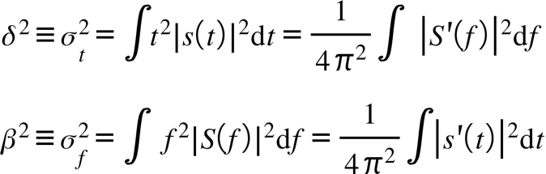

which are interpreted as the rms signal duration and rms bandwidth, respectively. The product of these quantities is known as the time-bandwidth product. Next, let us consider how phase modulation affects signal bandwidth. Substituting the derivative of s(t),

into the rms bandwidth and expanding

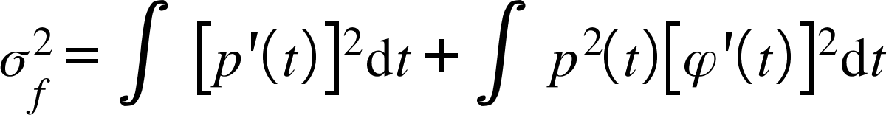

provides us with the answer. Any nonlinear phase function will increase the bandwidth, while a linear function will merely shift the frequency envelope. The second term in () indicates the effect of phase modulation on the bandwidth, thus we can write the total bandwidth

Anticipating a similar result in the dual domain reveals upon subsituting () into ()

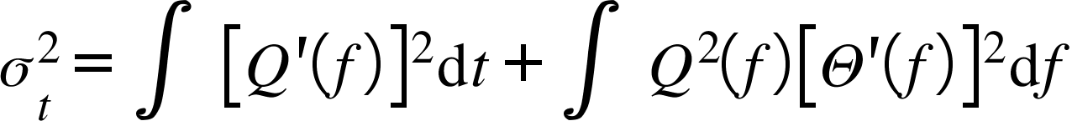

Therefore, phase modulation increases both the time and frequency spread and is known as pulse compression for reasons that will be addressed in Chapter 18.

Appling the Cauchy-Schwartz inequality (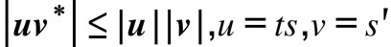 ),the square of the time-bandwidth product can be lower bounded as

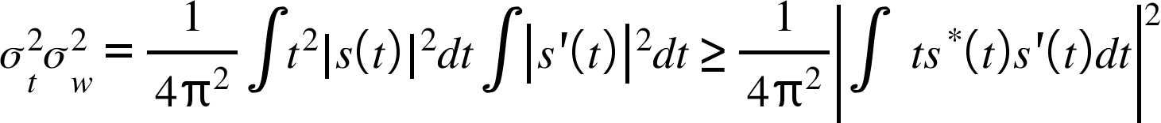

Substituting ()into () and converting to radian frequency produces the Gabor uncertainty relation

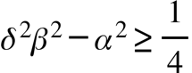

This generalized bound on the time-bandwidth product can be better appreciated by analogy with an ellipse in the time-frequency plane with equation

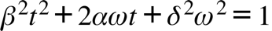

which,from (section LA) has area
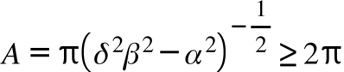

This relationship governs the volume distribution of combined delay and Doppler shift at the output of a matched filter receiver. The area cannot be made arbitrarily small so there will always be some uncertainty in the combined estimation of the parameters.

In absence of phase modulation (or constant) the linear FM coefficient is zero, therefore () has the particularly simple form for the product

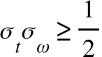

In Cauchy-Schwartz equality holds for proportional signals which leads to the differential equation

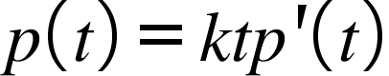

Integrating () we find the minimizing amplitude is the Gaussian pulse 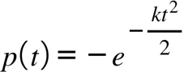.

Power, Signal-To-Noise Ratio, and Units

where is the processing gain of the receiver filter and is the signal to noise ratio in the front end receiver bandwidth.

For square integrable functions whose FT exists, the energy is

For functions of infinite extent, the energy is infinite, however the average power

may not be. These functions generally do not have a Fourier transform in the strict sense, though a FT may be coaxed into existence by multiplying by a suitable function to ensure convergence and then apply limiting arguments. For these so called power signals we define a power spectral density. Energy signals have zero average power because x^2 is finite. This class of functions is much larger than the square integrable class and includes them as a subset.

instantaneous power is v^2/R. Choose R to be one ohm and get amplitude squared. If x has units of volts then power is x(t) squared. Average power is instantaneous power integrated over the time duration of the signal.

has units of volts squared or energy, only after normalizing by impedance units, i.e. resistance, do we obtain Watts. I.e. is the instantaneous power through a 1 ohm resistor. The average power is the instantaneous power integrated over the duration of the signal if it is finite.

SNR is unitless, i.e. Energy/energy or power/power.

Matched Filter in White Noise

The correlator or matched filter is the optimum receiver structure in the sense of maximizing the SNR over an AWGN channel. The received signal at the front end of the receiver is, i.e. before the receiver filter

where is a known real deterministic signal of duration and energyand is white Gaussian noise with two sided power spectral density level . The output signal is

where is the causal impulse response with support on which we want to determine and now the noise is bandlimited. For a casual filter and time limited signal the two statements of convolution

are equivalent because for non-zero output. Therefore the combination of filtering and sampling illustrated in Figure () may be written as

Typically, however, in order to make convenient use of Fourier transforms we consider the finite support incumbent on the signal and thus leave the limits of integration as +/- infinity.

The SNR at the output of the receiver filter is

where (t) and (t) are the power in the filtered signal and noise respectively. The instantaneous signal power is

or in the frequency domain

The noise autocorrelation function is

and thus the noise power is

and is a constant function of time since the process is WSS. The noise power may also be computed in the frequency domain as

Using the Cauchy-Schwartz Inequality we upper bound the SNR after sampling at time kt, i.e. by

or,

Equality in is achieved iff the filter is of the form where is a constantand thus the SNR is maximized for the choice of filter with impulse response equal to a time reversed and translated replica of the input signal. Note also that the maximum possible SNR is independent of the filter and depends only on the signal energy (not the specific form) and noise level.

Substituting the optimal form for the signal output may expressed as

This is a correlation operation which again by the Cauchy-Schwartz inequality is maximized at the sample time. This is intuitively correct because is the area under the curve of the product of a shifted waveform with itself which is maximized for zero shift. Note that the output is has support on and decreases symmetrically and monotonically on both sides of . Also note the maximum value is the energy of the signal. If there is a timing error that samples at t=T+d then the SNR will degrade accordingly.

In the frequency domain the transfer function of the matched filter is

Since , the frequencies of the input signal are retained and out of band frequencies are rejected. Therefore, an approximation to a matched filter can be a bandpass filter of center frequency equal to the signal.

Matched Filter for Pulsed Sinewave

Example 1: Matched filter for a pulsed sine wave.

for The overlap may be divided into two regions and , during which non-zero overlap occurs for and , respectively. The total output is then

Since the matched filter operation is symmetric wrt , i.e. , we may evaluate only the first portion and then flip and shift it to form the second output. Expanding the cos term and neglecting the double frequency term

Figure () illustrates the matched filter output over time. It is maximum as expected at with valueand decays symmetrically according to a linear envelope.

Example 2: Performance effects of non-ideal filters.

For each filter the peak will have the form

where is the time at which the peak SNR is reached andis a measure of how much noise the filter passes which will obviously vary according to the filter. Note that the following filters are non-causal and hence not realizable, however, the analysis will still yield insight into the effects of non-ideal filters. The input signal will be the rectangular pulse

(a) Ideal LPF -

We have

which by symmetry is maximized at . Furthermore, to facilitate comparisons it is instructive to write the SNRs in the form

whereis a function that specifies the degradation from the optimal SNR. Making the change of variable we arrive at the expression for the peak SNR in the desired form

where .

For the purposes of comparison in what follows we assume that the parameters of the impulse response are such that the filter bandwidth is equal to, i.e.

(b) Two-sided exponential - .

The SNR at the output of the filter is

which is maximized again at and where

The peak SNR is then

where .

(c) Gaussian LP filter -

We have

which is again maximized at and where

By making the substitution the SNR may then be written as where .

The normalized peak SNR vs. the time (signal extent)-bandwidth (equivalent bandwidth) product for each filter is plotted in Figure (). These curves provide a loss measure for the degradation involved in using a “non-matched” filter. Also note that the optimum time bandwidth products range from .2 to .8.

Matched Filter in Colored Noise

For non-white noise the process of the optimum filter is to first whiten the noise and then correlate with a noise modified signal. see Rihaczek.

Finite Expansion of Signals and White Gaussian Noise

In a communication or detection system the received signal is

where X is a possible random distorted version of a deterministic transmitted signal s(t), and Z is a stationary white Gaussian noise process. We assume the complex case for the sake of generality.

We know from chapter 5 that any function in L2 may be expanded in a generalized Fourier series to yield an infinite sequence in l2. For signals processing one obviously cannot have infinite memory and hence finite dimensional signals are required. A theorem by Landau-shannon-slepian states that a signal approximately bandlimited W and T has approximately N=2WT dimensions for WT large.

For the noise process, the KL expansion converts the noise process to a set of independent Gaussian random variables .

Thus we have converted () to an N- vector relationship

Note that any ON set of basis function may be employed as only the coefficients matter. This makes analysis considerably easier. Therefore, in what follows, for detection, estimation, and communications applications, we restrict our development to vectors, i.e. digital signals.

Dimensionality

Talk about Gallager text, wozencraft

Some examples of basis functions follow.

Sampling of Continuous Time Signals

Suppose a communicator system transmits one of M waveformswith equal energy and equal apriori probability and receives the transmitted signal corrupted by an additive white Gaussian noise (AWGN) process as

Here we admit complex waveforms, which is the case for baseband transmission, and assume a signaling epoch of seconds and a signal bandwidth of Hz. Obviously, a waveform cannot be simultaneously both time and frequency limited, but many signals have most of their energy constrained to these regions, and it is in this sense that we use T and W. It is convenient not only for digital processing, but for analysis as well, to convert these waveforms to finite vectors of some adequate dimension which preserves the signal characteristics in such a way that sufficient information is not lost to permit a reconstruction of the time waveform in terms of its vector representation. We do this by invoking the generalized Fourier series discussed in chapter 5.

One possible choice of basis functions are the so called sampling functions

which precisely constrain the bandwidth of the signal to and the time extent to approximately . Waveforms capable of being expanded in a series of this type are the class with maximum frequency W or bandlimited to . The sampling frequency is .

To see that these basis functions are indeed orthogonal we take its generalized Fourier transform and use Parseval’s relation. Specifically,

and then by using Poisson’s formula we arrive at the orthogonality condition

The Fourier series coefficients are the scaled waveform samples

The ease with which the coefficients can be computed makes the sampling basis an attractive choice. The world of digital signal processing has much to say about sampling. Especially, since signals are always only approximately bandlimited.

Another possible choice is the Fourier series basis which are the dual of the sampling functions.

Analog Modulation Techniques

Suppose you want to transmit a typical voice audio signal somewhere. If it is not far perhaps you may use a wire that supports the 4kHz bandwidth. What if you want to send it to multiple destinations that are very far away. You could use cables as in cable television. What if the users are moving? Then certainly you cannot use wires. The transmission over wireless channel to multiple possibly moving users is called the broadcast channel.
why use a carrier? 1) reception is easier, audio signals are 4000 Hz which would require a quarter wavelength antenna long.
2) if each carrier frequency is different, more signals can occupy the same time slot. This is called FDMA.

1) carrier wave shifts baseband frequencies into the passband of the channel
2) reduces antenna size
3) allows transmission to multiple simultaneous users

Amplitude Modulation

Let us assume that m(t) is a windowed sine wave with a very long window length and a frequency . When m(t)<0 a phase shift of 180 is incurred in the carrier, therefore we may write as

where

The spectrum of such a signal is, by the convolution property of Fourier transforms,

The above type of modulation is known as carrier suppressed AM for reasons that will soon be apparent. CS-AM is difficult to demodulate because a reference carrier is not available for coherent demodulation techniques and non-coherent methods that use an envelope detector work poorly when the modulated signal becomes negative.

To address this issue we insert a DC component to ensure that the amplitude factor never becomes less than zero. This type of modulation is called standard AM and has the form

where is the modulation index and is the amplitude of m(t) . If the m(t) has unit amplitude in the case of a sine wave, or has its most negative value equal 1, then a modulation index ensures positive amplitude for all time.

Demodulation

The incoming carrier frequency is mixed down to a lower frequency for ease of processing and bandpass filtered around this frequency. For demodulation we assume narrowband white Gaussian noise expanded about of the form

so that the total received signal

is

where is the envelope extracted by an assumed ideal envelope detector and is the phase. The desired signal to be recovered is contained in the envelope. If we assume that on average the signal quantity then we may neglect the noise and approximate the envelope as

The noise component is filtered by an ideal bandpass filter Hm with bandwidth equal to M(f), 2Bm. The total noise power in the noise is then

The signal power for is

so that the signal to noise ratio is

Phase modulation

In phase modulation

Performance

Coherent Detection

Coherent correlation detector
First we examine the synchronous demodulation of double side band suppressed carrier transmission were the local oscillator at the receive is exactly matched to the carrier frequency. The received waveform at the input to the receiver is

Single sideband detection

Incoherent Detection

Double Side Band transmitted carrier:

Amplitude is large enough to permit envelope detection, i.e. envelope absolute value is always positive, mod index >1.

Frequency Modulation

In frequency modulation (FM), the message signal is contained in the frequency variation of the carrier. The instantaneous carrier frequency is proportional to the message signal and has the form

where again we assume m(t) is unit amplitude. The parameter then is the maximum deviation in carrier frequency and is known as the frequency deviation coefficient. Because frequency is the derivative of phase, the modulated carrier is

so that FM is a special case of PM where . In what follows we assume for tractability purposes that so that takes the form

where is the ratio of maximum deviation to modulation frequency and is known as the modulation index.

The input to the demodulator is the signal plus noise waveform

where

and

Demodulation is performed by a frequency detector whose output is

Performance

Discriminator detector

Derivative followed by envelope detector

